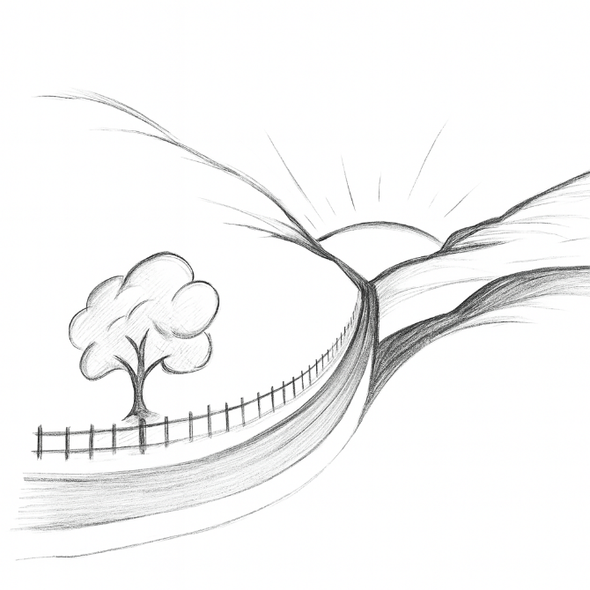
Valley Mental Health and Wellness
Suzanne M Ward,
Psychiatric Mental Health Nurse Practitioner
Serving the rural valleys and communities of central PA.

Recipe for Wellness
To increase knowledge and understanding of mental illness, mental health, and overall wellness by providing information and education.
Issue #1

Supporting Our Neighbors
“Bear one another’s burdens, and so fulfill the law of Christ.”
-Galatians 6:2

It can be difficult to bear our neighbor’s burdens when we don’t understand or know what they need. Here are ways you can help support your neighbors when they or their family is struggling with a mental illness:

Help them feel and stay connected with their family and community. Talk with them as you would talk with anyone, laugh with them, pray with them.

Help them feel hopeful that their life can and will be better; that wellness is something that can be achieved and maintained.

Remind them of who they are - father, mother, son, daughter, friend, neighbor – they are so much more than their illness.

Support and offer opportunities for them to use their strengths and skills to fulfill meaningful work and activities.

Support what helps them heal. Do not judge them but encourage them and empower them to be well and stay well.

And God said, “Let there be light,” and there was light. And God saw that the light was good. And God separated the light from the darkness.”
Genesis 1:3-4
(this is a separate quote not connected to any article but should be positioned close to the information about depression below)

What am I feeling?
Everyone feels sadness, but sometimes what we feel is different. What we feel is heavier, lower, darker than sadness. Maybe what we feel is depression. Depression is an illness of the brain that can happen to anyone and is not always understood. Here are 9 questions to think about.
Most days over the past 2 week…
Have you stopped feeling interested in things you used to enjoy?
Have you been feeling down and haven’t been able to get back up, feeling empty or having little hope?
Have you been feeling worthless?
Have you been having trouble with your sleep?
Have you been feeling more tired than usual or have little energy to do your work?
Have you been eating more or eating less?
Have you been feeling bad about yourself?
Have you been having trouble concentrating or focusing on your work?
If you answered yes to more than half of these questions, talking to someone can start the journey to feeling better.

What’s All This About Magnesium?
Magnesium is an essential mineral that helps our bodies run smoothly. It has a role in the health of our muscles, nerves, bones and energy production. Getting the right amount can help relieve muscle cramps, constipation, poor sleep, high blood pressure, insulin resistance, and fatigue. Most of us get all the magnesium we need in a day, between 250 and 500 milligrams, through the foods we eat. Here are some examples:
1 oz roasted almonds = 80 mg
1 oz roasted cashews = 72 mg
1 oz roasted pumpkin seeds = 150 mg
1 oz dry roasted peanuts = 49 mg
1 tablespoon whole flaxseed = 40 mg
½ cup black beans = 60 mg
½ cup lima beans = 40 mg
½ cup cooked spinach = 78 mg
½ cup cooked swiss chard = 75 mg
½ cup collard greens = 25 mg
1 cup shredded wheat = 56 mg
1 cup nonfat milk = 24-27 mg
8 oz plain low-fat yogurt = 42 mg
1 whole avocado = 58 mg
1 medium banana = 32 mg
1 cup blackberries = 29 mg
½ cup green peas = 31 mg
½ cup sweet corn = 27 mg
1 medium potato with skin = 48 mg

If we are not getting enough magnesium through our diet, taking magnesium supplements might help. Supplements contain different types of magnesium, and it can be helpful to know what they are and what they can do.
Magnesium citrate - easy for the body to absorb but can cause diarrhea.
Magnesium glycinate - gentle on the stomach and calming; may help with sleep, stress, and anxiety
Magnesium L-threonate - A newer formula that can cross into the brain and may support memory and mood
Magnesium malate or lactate - easy to digest and may help with energy
Magnesium oxide - poorly absorbed in the body and often used to relieve constipation
Magnesium sulfate - found in Epson salts and can help sore muscles as a soak. Does not raise magnesium levels through the skin
Magnesium taurate - often used to support heart health and blood pressure

*Individuals with kidney disease should not take magnesium supplements unless directed by their doctor.

Read All About It!

Know what you are taking - reading the back of the bottle is just as important as reading the front.
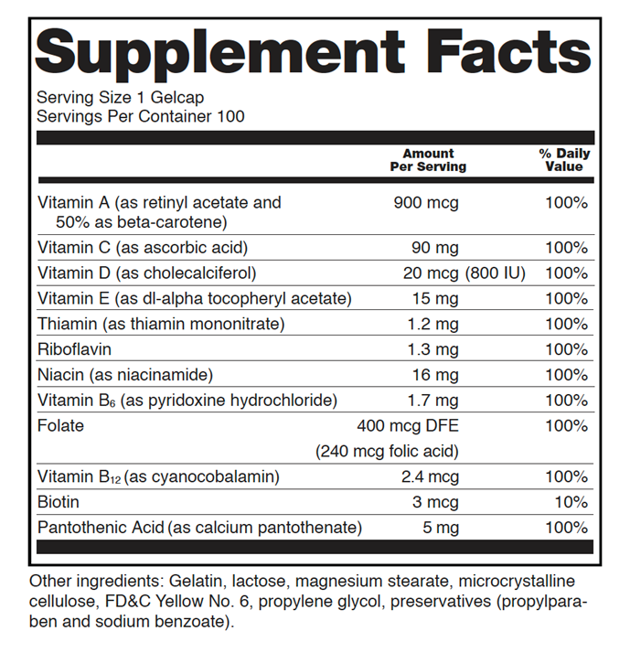
Serving Size – how much you should take to get the amount of each ingredient and the percentage (%) of daily value listed on the label.
Servings Per Container – This can help you decide value – will the supplement last 2 weeks or a month if you take the serving size.
Amount Per Serving – This is the amount of the ingredient for each serving. Usually given in micrograms (mcg), milligrams (mg), or international units (IU).

% Daily Value – This tells you what percentage of the recommended daily intake for each nutrient is in each serving. 100% is the minimal amount needed (remember, you are also eating foods that will also provide what your body needs and will add to the total daily percentage).
Dietary Ingredients – This tells you what is in the supplement – a dietary ingredient can be a vitamin, mineral, botanical, amino acid, dietary substance, concentrate, metabolite, or extract.
Other Ingredients – This includes all the other ingredients in the supplement; these are listed in decreasing order by amount in the supplement.

Sometimes supplements will have Proprietary Blends listed. These are dietary ingredients that are not considered nutrients. The names and amounts of the ingredients will be listed, but not how much of the ingredients are in the supplement.

Watch for doubles and triples of ingredients if you are taking more than one supplement - make sure you are not taking too much of a good thing.

Suzanne M Ward
Psychiatric Mental Health Nurse Practitioner

Valley Mental Health and Wellness
100 Stine Dr. Ste A Lewistown, PA 17044
(717) 310 9256 or (814) 422 3353
Offices located in Lewistown and Mifflinburg
Call to schedule an appointment

